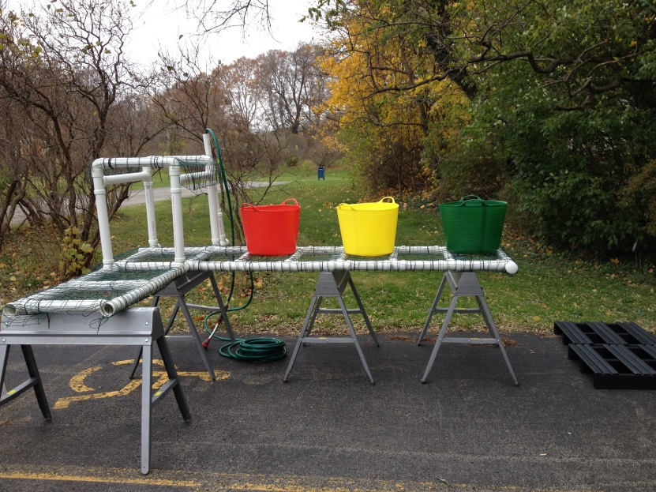

**Farm Food Safety:**

**Standard Operating Procedure for Washing Produce   
with a Peracetic Acid Solution**

This standard operating procedure will guide you through the steps necessary to wash produce in a food safe manner. From calculation of sanitizer rates to washing procedures, many variables can affect the safety of produce on your farm. Use this SOP to learn how to use sanitizers in your produce washing procedure, for training employees and future reference.

**Materials**

* 3 wash tubs/basins
* Potable water
* Plastic or metal long handled stirring spoon
* Peracetic acid product
* Peracetic acid test strips
* pH test strips
* ORP meter *(optional)*
* pH meter & buffer solutions *(optional)*

*Preparation*

Several OMRI certified sanitation products are mixtures of the active ingredients hydrogen peroxide and peracetic acid (PAA, also called peroxyacetic acid). Acceptable PAA concentrations for sanitizing solutions are 24-85 parts per million (ppm) of PAA, depending on the product being washed. T**he general recommendation is a 60 parts per million (ppm) solution of PAA for washing produce using submersion systems.**

**Prior to mixing the Sanitizing Solution**

1. Use a Peracetic acid (PAA) product labeled for the sanitation of surfaces and produce.
2. Calculate the amount of sanitizer product required to achieve the desirable PAA concentration using the formulas on the next page.
3. Inspect washtubs and clean them if necessary.
4. Fill washtubs with the target amount of potable water (ex. 5 gallons).

**Mixing the Sanitizing Solution**

1. Add the calculated amount of PAA product to the each wash and stir using the plastic or metal stirring spoon.

2. Use a **peracetic acid** test strip to measure the **peracetic acid** concentration, following instructions on the container.  
  
 **If target peracetic acid** **concentration** **is not achieved, add small increments of product until the target is achieved.**  
  
3. Proceed to produce washing once peracetic acid and pH are within acceptable ranges.   
4. Use this calculated amount of sanitizer for future wash water solutions. Double check levels with monitoring strips.

Figure 1.*Photo:*

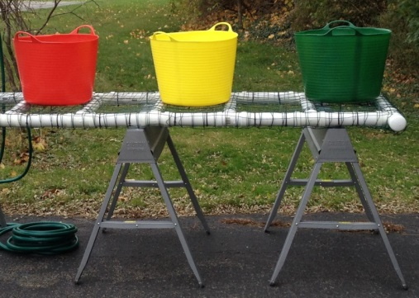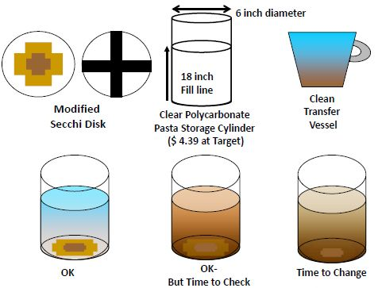

**Conversion factors**

1% = 100 ppm (parts per million)   
1 gal = 768 teaspoons  
1 fluid ounce = 6 teaspoons

**Volume PAA product needed = Desired ppm PAA x volume of wash water  
 % PAA in product x 10,000**

**Note:** Some manufacturers include a recommended rate in fluid ounces on the label. In this case, follow the label rate. For example, the rate recommended by BioSafe to achieve 60 ppm of SaniDate 5.0 is 0.13 ounces per gallon of water.

*Although 60 parts per million can be used as a general rule for peracetic acid concentration for dunking fresh produce, please refer to the label and associated materials referring to the specific product you choose to use.

Volume SaniDate 5.0 needed = 0.13 ounces SaniDate 5.0 x 5 gal of wash water  
  
Volume SaniDate 5.0 needed = 0.65 ounces SaniDate 5.0   
Now convert the amount of SaniDate 5.0 needed to teaspoons: 

Volume of sanitizer needed = 60 ppm free chlorine x 5 gal of wash water  
 5.3% PAA in sanitizer x 10,000

Volume of sanitizer needed    
Now convert the amount of sanitizing product needed to teaspoons

Volume of sanitizer needed 

**The current recommended level is 60 ppm solution of PAA for washing produce.\*** Using this level, the volume of wash water per washbasin and the PAA concentration in your sanitizer product, calculate the amount of sanitizer needed per washbasin. The formula below can be used to calculate the amount of PAA product per washbasin for your given volume of water. Once you have determined the amount of sanitizer needed for a given quantity of water, you can use that level in the future without recalculating. PAA levels remain stable even when organic matter is introduced. Double check levels with monitoring strips.

*Calculating Peracetic Acid Levels*

**Washing Produce with a Sanitizing Solution**

*Spray Rack*

1. Attach a turbidity indicator card to the bottom of a clear container (6”x18” or about 5.5qt or a 1/2gal mason jar).  
2. Fill container with water from sanitizer or rinse bucket  
3. Looking down from the top of the container, look at the card on the bottom of the container.  
4. If you can see the white area, then the water does not need to be changed.  
5. If you can see the light brown area, the water is still usable but you will have to change it soon.  
6. If you can see only the dark brown area, or cannot see the card at all, change the water.

*Testing Turbidity*

**Washing Produce with a Sanitizing Solution**

*Washing Procedure*

1. Place produce into the first tank. It must stay in this first rinse at least 1 minute.

* Depending on type of produce, dunk, re-dunk, agitate or whatever is necessary to remove debris and soil from produce.

2. Dunk produce in each of the two rinse containers. This will allow for further cleaning and will remove residual chlorine.

* Add a small amount of sanitizer to even the rinse containers (target between 5 and 10 ppm free chlorine) to prevent the build-up and cross-contamination of pathogens to produce.

3. After a few batches, check the free chlorine level and turbidity of the wash solution.   
 Free chlorine levels will fall and turbidity will increase as organic matter comes off produce.

4. Periodically test the turbidity of the rinse water.

5. Replace sanitizing solution if turbidity is too high or if free chlorine levels are too low.

6. Clean and sanitize all wash containers and food contact surfaces after done.

This material is based upon work supported by USDA/NIFA under award number 2012-49200-20031.

Prepared February 2015 by Cordelia Hall

**Project Coordinator:** Robert Hadad, Extension Vegetable Specialist , Cornell Vegetable Program

rgh26@cornell.edu