 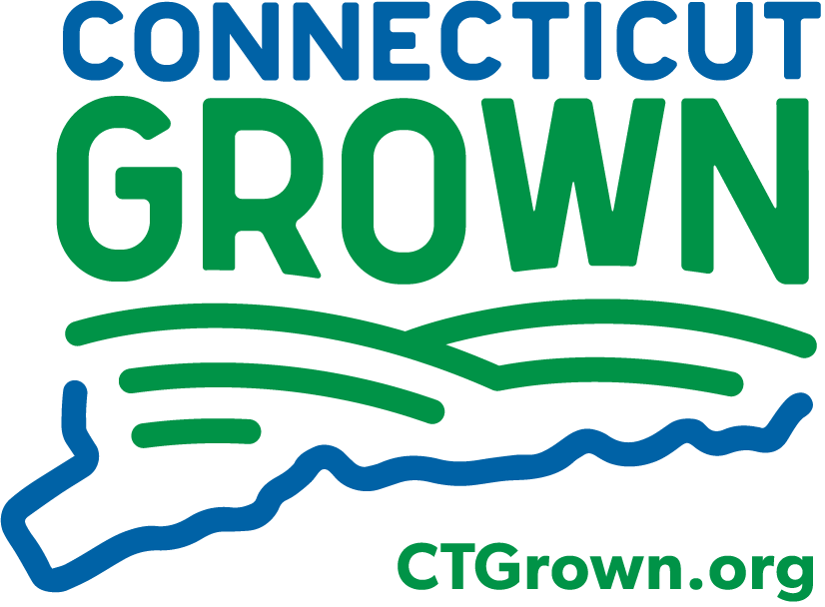

**2025 FSMA Produce Safety Rule/Produce Safety Alliance Approved Grower Training Courses**

Two PSA Grower Training Courses are presently scheduled for late winter 2025. Registration is first come, first served, so please register early, no matter which course you plan to attend.

**REGISTRATION: Course fees are $50.**

**TO REGISTER ONLINE VISIT:** <https://s.uconn.edu/fsmaproducesafety>

The preferred method of registration/payment is through UConn Marketplace, paying with a credit card. Please include your phone number and regularly used email address in case of emergency or cancellation. **If you choose to register by mail (not preferred) please see the registration form on the next page.**

**Instructors:**

· Indu Upadhyaya, Ph.D., Food Safety Specialist, UConn Cooperative Extension

· Diane Hirsch, MPH, Food Safety Specialist, UConn

· Jacqueline Kowalski, Urban Agriculture Specialist, UConn Cooperative Extension

**Course Summary:** The Produce Safety Alliance (PSA) Grower Training Course has been designed to provide a foundation of Good Agricultural Practices knowledge that includes emphasis on co-management of food safety and environmental management goals, while outlining the requirements of the Food Safety Modernization Act (FSMA) Produce Safety Rule. The PSA Grower Training Course is one way to satisfy the FSMA Produce Safety Rule requirement outlined in § 112.22(c) that requires ‘At least one supervisor or responsible party for your farm must have successfully completed food safety training at least equivalent to that received under standardized curriculum recognized as adequate by the Food and Drug Administration.’

**To obtain a certificate that provides evidence of compliance with the training requirements of the rule, you must be present for the entire two-day course, so do not make plans for the snow date!**

**REGISTRATION FORM**

**Registration Deadlines:**

**In-Person course: February 24**  **Virtual course: March 10**

**(Space for In-Person course is limited to 30 participants)**

For additional information or if you have a question regarding this course, contact: Indu Upadhyaya at

860-786-8191 or [indu.upadhyaya@uconn.edu](mailto:indu.upadhyaya@uconn.edu)

If you are an individual with a disability and need accommodation, please contact Indu Upadhyaya at [indu.upadhyaya@uconn.edu](mailto:indu.upadhyaya@uconn.edu) or call her at 860-786-8191 as early as possible prior to the event to help us ensure availability. Please be aware that advance notice is necessary as some accommodation may require more time for the University to arrange. A good faith effort will be made to provide accommodation up until the time of the workshop.

**TO REGISTER ONLINE VISIT:** <https://s.uconn.edu/fsmaproducesafety>

**REGISTER BY MAIL: Enclose a registration form and check for $50 per person, payable to the** **University of Connecticut.** There will be no refunds after the registration deadline.

**MAIL TO:**

Indu Upadhyaya/PSA Course

Tolland County Extension Center

24 Hyde Ave, Vernon, CT-06066

"…………………………………………………………………………………………………………

Please check which course you are attending: ¨ March 26, 27 OR ¨ April 8, 9

Name:

Farm name/operation:

Mailing address:

Phone: (to be used in case of weather cancellation or delay)

Email address:

Please advise of any special dietary or other accommodations here:

